Additional services offered at select times during the year. Call for more information

**Exfoliation Treatments**

**Back & Body Treatments**



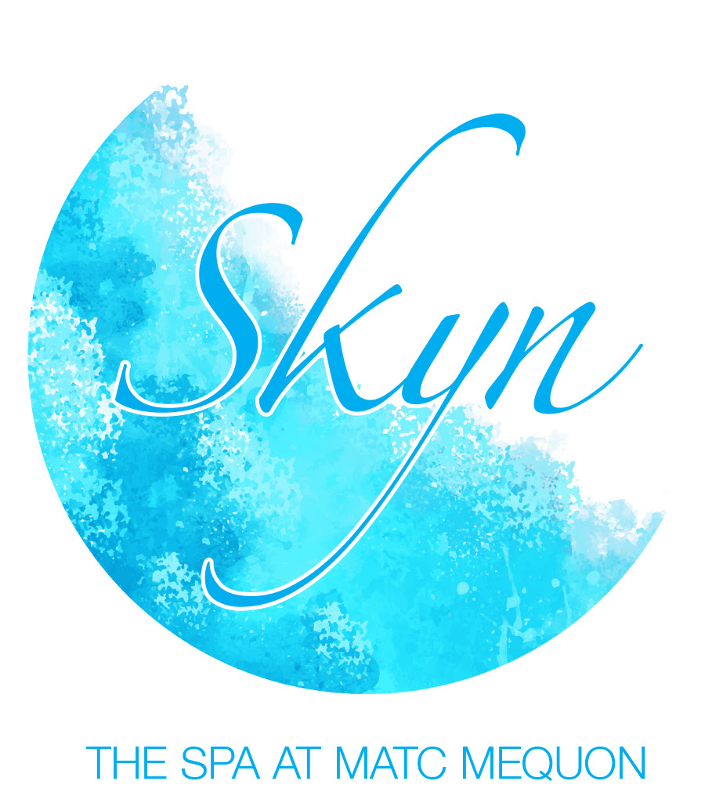

re

5555 W. Highland Rd

Room A-233

Mequon, WI 53092

Phone: 262-238-2222

**Pumice Peel**

**Manual Microdermabrasion Facial …...$30.00** This is an ideal option for those who want the effects of microdermabrasion without the machine. The ultra-fine pumice crystals in this machineless treatment peel away dull, dreary cells, abrade uneven skin, and help reduce the appearance of fine lines and wrinkles. The result will be brighter skin.

**Machine Microdermabrasion Facial ..........40.00**+ Rejuvenate your skin, reduce minor to moderate fine lines around your eyes and forehead, and reduce hyperpigmentation and oily skin with this wonderful alternative to laser or chemical peels. Your skin will have a radiant glow. You will experience softer, smoother, and cleaner skin after the first treatment. (45 Minutes)

Crystal Microdermabrasion………….$40.00

Diamond Microdermabrasion…….....$50.00

HydraFacial ………………….……….$75.00 -$145.00

**Bioelements Powerful Surface Peel ………….$40.00**

Your skin's introduction to a peel begins here. Potent but gentle lactic acid, plus exfoliating pumpkin fruit acids and stimulating pomegranate zero in on premature age signs, with zero recovery downtime. Ideal for inflamed breakout-prone skin, surface wrinkles, and even post-acne dark spots. You'll see an increase in hydration, as skin emerges visibly clearer, brighter and less lined. Achieve the best results with a series of treatments. (60 minutes)

**Bioelements Fast Results Peel……………$30.00** Concerned with skin-aging - particularly lines, surface wrinkles, dull skin, clogged pores, and rough skin texture. This advanced, ultimate-strength 'quick peel' contains potent organic lactic acid and exfoliating pumpkin and pomegranate fruit enzymes. They'll provide a powerful peeling of dulling surface cells. It's the fastest way to smooth out fine lines and wrinkles, leaving the client's skin feeling refreshed and younger looking. (30 Minutes)

**262-238-2222**

<http://skyn.skincaretherapy.info/home>

**De-stressing Back Treatment...................$20.00**

This treatment will relax you using warm oils and hot towels. We cleanse the skin and give a relaxing massage. It is not a deep tissue back massage, but a relaxation treatment. (30 minutes)

**Back Facial Mask Treatment ....................$30.00** Your skin will be cleansed, toned, exfoliated with a body brush, massaged, and masked. Warm towels and a heat lamp will relax you. Great for everyone. (45 minutes

**Aromatherapy Body Wraps.............................$40.00**

**Scents: Champagne & Rose -** Or **- Green Tea**

Embark on a sensory journey that incorporates healing touch and aromatherapy to promote deep relaxation and soft skin. The treatment begins with an invigorating exfoliation followed by neck to toes application of therapeutic aromatherapy oils. You’ll drift into a state of complete relaxation as the fragrant molecules of warm oil penetrate your skin. When you emerge from your relaxation, you will be completely de-stressed with unbelievably smooth, soft skin. (60 minutes)

**Herbology Body Retexturizer Wrap…..…..$45.00** Smooth and retexturize your skin from neck to toes with medicinal Chinese herbs. It starts with an application of warm Citrus Fruit Massage Oil followed by an exfoliating Herbology massage. You’ll then be cocooned in heated thermal blankets to melt the therapeutic granules into your skin. The result will be silky smooth, revitalized skin that will feel comfortable for days. (60-75 minutes)

# *Skyn*

## Service Menu

**Stand Alone or Add On Services**

**Makeup Applications**

**Foot & Hand Facials**

**Add On Services**

**Waxing Services**

### **Advanced Facial Treatments**

Additional services offered at select times during the year.

Call for more information

**Facials with Machines**

**Machine Facial ..**(Great for Men)**................$40.00** Beneficial for skin types. We deep cleanse the skin using a rotary brush followed by galvanic current to soften blackheads, ingrown hairs and prepare for extractions. Next experience the deep penetrating germicidal action of high frequency current to target any breakouts. All this, plus a relaxing massage of the face, neck, shoulders and a custom blend mask to soothe, balance and tone your skin. You’ll emerge looking and feeling like a million. (60 Minutes)

**Ultrasonic Facial ……………………………$40.00**

After deep cleansing and exfoliation with a dermafile, ultrasonic waves loosen debris from your pores through vibration. Relax during a massage followed by a custom mask. Finally ultrasonic waves will push a specialized serum into your skin. (60 min.)

**Ultimate Age-Defying Facial …………….$75.00**

This amazing treatment will use multiple new technologies to tone facial muscles, stimulate collagen and elastin, and increase cell metabolism. Experience uplifting facial toning from NuFace, followed by an LED Treatment. We will also use Ultrasonic soundwaves for both deep pore cleansing and serum penetration. See a noticeable improvement in facial definition. (90 min)

**NuFace Microcurrent Treatment** (15 min.) **.$15.00**

**LED Light Treatment** (15 min )……**………..$10.00**

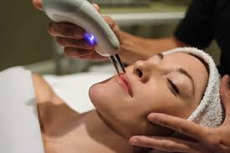

**Bioelements Elite Facial .............................$40.00** Designed for your exact complexion, this personalized facial is totally customized from start to finish! You’ll experience a custom blended deep pore cleansing, exfoliation, steam, extractions, massage of the face, neck, and shoulders, followed by a therapeutic Bioelements mask and serum designed to correct specific problems. Emerge with immaculately clean, smooth, and glowing skin. **(60 Minutes)**

**Modifications to the Elite Facial Include:**

**Calming Facial …..............$40.00**

Gentle massage techniques are paired with skin-calming ingredients to help the most delicate, red, and sensitive skin rebalance and renew.

**Flaxx-C Anti-aging Facial ..$40.00** Breakthrough treatment for skin that’s showing signs of age–sagging, fine lines, and dullness. Featuring an exclusive layered exfoliation process, energizing massage and ultra-tightening mask.

**Acne Clearing Facial……....$40.00**

Designed for stubborn chronic acne, hormonally induced breakouts or simply clogged pores and blackheads. Deep pore cleansing with exfoliation to target any breakouts, and a salicylic acid medicated power treatment and sulfur Amino Mask with enzymes, AHA’s, antioxidants, antiseptic and anti-inflammatory ingredients.

All waxing prices depend upon the amount of hair and the amount of wax needed for removal.

**Eyebrows .........................................$8.00**

**Facial Hair ........................................$8.00 Underarms ......................................$10.00**

**Legs (half from knee down) ..........$15.00**

**Legs (full legs) ................................$30.00**

**Bikini wax (second semester)........$20.00**

**Back .................................................$30.00**

**Nose ………………………….…..…….$8.00**

### **Services – Offered Year Round - Except during school breaks**

**Bioelements Mini Facial …………...……$20.00** Relax and Enjoy as we analyze, cleanse, tone, massage and moisturize your skin. This facial will give your skin a new glow. (30 minutes)

**Exfoliating Facial.....................................$30.00**

This facial removes dry patches on dry to oily skin, loosens blackheads, and cleans out pores. We choose a mask for your skin type. It leaves the skin very soft and has a warm effect.

**Custom Blends: ...……………..…………….$10.00**

*Added to Facial Mask or Power Treatment

**Finishing Serums: ………………………….$3.00 each**

*Serums deliver targeted ingredients for improved skin tone, smoothness, fine lines, mega-burst of antioxidants, hydration and more..

**Paraffin Treatment for Hands or Feet........$10.00**

* **Combined with any other treatment. ...$7.00**

**Elite Foot or Hand Facial...........................$15.00**

* Treat your feet a relaxing soak, then we exfoliate the dead skin cells, massage, mask, and moisturize. Your feet or hands will smell and feel great! (30-45 minutes).

**Mineral Makeup ……………….…………….$10.00**

**Airbrush Makeup (Advanced) ………$10.00 & up**